
JAIDEV EDUCATION SOCIETY’S
J D COLLEGE OF ENGINEERING AND MANAGEMENT
KATOL ROAD, NAGPUR
Website: www.jdcoem.ac.in E-mail: info@jdcoem.ac.in
An Autonomous Institute, with NAAC "A" Grade
Affiliated to DBATU, RTMNU & MSBTE Mumbai
“A Place to Learn, A Chance to Grow”
Department of Computer Science & Engineering
2024-25
VISION | MISSION
To be recognized for excellent engineering, developing global leaders both in educational and research in the domain of computer science and wireless engineering. | 1. To create self-learning environment by facilitating leadership qualities, team spirit and ethical responsibilities.
 | 2. To improve department-industry collaboration, interaction with professional society through technical knowledge and internship program.
 | 3. To promote research and development with current techniques through well qualified resources in the area of computer science and wireless engineering.

Principle of Corporate Success

Branding report submitted in partial fulfilment of the requirements for the award of the degree of
Bachelor of technology

In
Specialization
Computer Science and Engineering
Submitted by
Arya Surkar
(CS20)
Under Guidance of
Prof. Gauri Thakre

JAIDEV EDUCATION SOCIETY’S
J D COLLEGE OF ENGINEERING AND MANAGEMENT
KATOL ROAD, NAGPUR
Website: www.jdcoem.ac.in E-mail: info@jdcoem.ac.in
An Autonomous Institute, with NAAC "A" Grade
Affiliated to DBATU, RTMNU & MSBTE Mumbai
“A Place to Learn, A Chance to Grow”
Department of Computer Science & Engineering
2024-25
VISION | MISSION
To be recognized for excellent engineering, developing global leaders both in educational and research in the domain of computer science and wireless engineering. | 1. To create self-learning environment by facilitating leadership qualities, team spirit and ethical responsibilities.
 | 2. To improve department-industry collaboration, interaction with professional society through technical knowledge and internship program.
 | 3. To promote research and development with current techniques through well qualified resources in the area of computer science and wireless engineering.

CERTIFICATE

This is to certify that Arya Surkar has submitted the project report "Branding and Marketing Strategy Temperature Controllable Gaming Chair”, towards partial fulfilment of BACHELOR OF Engineering degree examination. This has not been submitted for any other examination and does not form part of any other course undergone as prescribed by JD College of Engineering and Management, Nagpur. It is further certified that he has ingeniously completed his project.

Gauri Thakare
(Project guide)

Place: Nagpur Arya Surkar
Date: 11-04-2025


JAIDEV EDUCATION SOCIETY’S
J D COLLEGE OF ENGINEERING AND MANAGEMENT
KATOL ROAD, NAGPUR
Website: www.jdcoem.ac.in E-mail: info@jdcoem.ac.in
An Autonomous Institute, with NAAC "A" Grade
Affiliated to DBATU, RTMNU & MSBTE Mumbai
“A Place to Learn, A Chance to Grow”
Department of Computer Science & Engineering
2024-25
VISION | MISSION
To be recognized for excellent engineering, developing global leaders both in educational and research in the domain of computer science and wireless engineering. | 1. To create self-learning environment by facilitating leadership qualities, team spirit and ethical responsibilities.
 | 2. To improve department-industry collaboration, interaction with professional society through technical knowledge and internship program.
 | 3. To promote research and development with current techniques through well qualified resources in the area of computer science and wireless engineering.

DECLARATION

I here-by declare that the project with title "Branding and Marketing Strategy Temperature Controllable Gaming Chair”, has been completed by me in partial fulfilment of BACHELOR OF Engineering degree examination as prescribed by JD College of Engineering and Management, Nagpur and this has not submitted for any other examination and does not form the part of any other course undertaken by me.

Place: Nagpur Arya Surkar
Date: 11-04-2025


JAIDEV EDUCATION SOCIETY’S
J D COLLEGE OF ENGINEERING AND MANAGEMENT
KATOL ROAD, NAGPUR
Website: www.jdcoem.ac.in E-mail: info@jdcoem.ac.in
An Autonomous Institute, with NAAC "A" Grade
Affiliated to DBATU, RTMNU & MSBTE Mumbai
“A Place to Learn, A Chance to Grow”
Department of Computer Science & Engineering
2024-25
VISION | MISSION
To be recognized for excellent engineering, developing global leaders both in educational and research in the domain of computer science and wireless engineering. | 1. To create self-learning environment by facilitating leadership qualities, team spirit and ethical responsibilities.
 | 2. To improve department-industry collaboration, interaction with professional society through technical knowledge and internship program.
 | 3. To promote research and development with current techniques through well qualified resources in the area of computer science and wireless engineering.

ACKNOWLEDGEMENT

With immense pride and sense of gratitude, I take this golden opportunity to express my sincere regards to Dr. Supriya Lanjewar, HOD Computer Science and Engineering Department, JD College of Engineering and Management, Nagpur. I am extremely thankful to my project guide Miss. Gauri Thakare for the guideline throughout the project by giving me outstanding guidance, enthusiastic suggestion and invaluable encouragement which helped me in the completion of the project. I will fail in my duty if I do not thank the non-teaching staff of the college for their cooperation. I would like to thank all those who helped me in making this project complete and successful.

Place: Nagpur. Arya Surkar
Date: 11-04-2025
Index
Sr no. | Particulars | Page no.
1. | S Introduction:  Company Overview  Addressed Problem  Pre-existing Research  Consumer preference | 1
2. | Methodology:  Data Collection  Unique Design  Resource identification | 2
3. | Strategy:  Objective & Scope  Marketing  Unique Design  Collaboration | 2-3
4. | Pretesting:  Resource Allocation  Manufacturing base Model  Beta trials | 3-4
5. | Concurrent Testing:  Market Launch  Feedback  Improvement | 4-5
6. | Post testing:  Upgradation  Feedback response  Sales and Revenue | 5-6
7. | Result and Conclusion | 7-8

Temperature Controllable Gaming Chair

Introduction
Professional gamers spend long hours in immense gaming which can lead to discomfort, fatigue, and reduced performance. The idea is to design a next generation gaming chair to provide maximum comfort for the long gaming sessions. It promotes the proper posture design so that gamers stay focused on games.
Most unique idea here is that integrate the temperature controllable bladeless fan which provides the cooling or heating to the pivotal parts of the body like neck, wrist and elbow. Here the integrated cooling and heating fan system ensures efficient power output, delivering smooth and continuous full-body airflow while keeping noise levels as soft as a whisper.
The cooling and heating mechanism helps the gamers to maintain the body temperature and reduce sweat which enhances the overall gaming performance. Exceptional feature provided to chair is the fingertip controllable system that allows to control the temperature manually or automatically according to the surround to provide the enhanced gaming experience.
This innovative gaming chair redefines comfort and performance, helping serious gamers, streamers, and esports professionals achieve enhanced focus and endurance through unique design, bladeless cooling technology, and adaptive smart features.

Tagline:

"Where Comfort Meets Competitive Edge."

Methodology:
- To design such type of chair we analysed the all-existing gaming chair to figure out to make unique chair design to fulfil all the requirements of the comfort perspective.
- Then we designed such a cooling and heating system that has bladeless fan to provide the cooling and heating without noise that allow the gamers to have the gameplay experience without distractions.
- To optimize comfort and temperature control we equipped the chair with the sensors with the high precision so that chair have an ability to adjust the temperature with respect to the surrounding.
- We built the chair with the high-quality material which has have highly durability and breathable mesh to provide ultimate comfort.
- We have made this chair an essential addition to any gaming setup which helps to enhance the gaming experience in the real world.
- We combined RGB lights to the gaming chair for the aesthetic look with the durable and comfortable material.
- Before launching chair in the market for gamers it will undergo the lab testing to check the performance and durability of the chair.

Strategy:

- This gaming chair is specially designed for the serious gamers, streamers and esports professionals to provide the both performance and comfort as per the demand of gamers.
- For the marketing strategy we hosted interactive booths at the at the esports tournaments and tech expos so that our chair gets more validation from our target audience i.e. hardcore gamers.
- We did collaboration with the gamers, streamers, and tech reviewers to increase the awareness about our chair among our target audience.
- We used social media for promotion platforms like TikTok, Instagram, YouTube and Facebook to promote our chair with the help of ads floating on these platforms.
- We kept our chair budget friendly so that we grab the majority of the market by providing the premium quality product in the low cost.
- We secure partnership with the gaming accessory retailers and list on leading e-commerce platforms like Amazon & Flipkart to have the marketing advantage for a whole new product in the market.
- We also provided the warranty and repair service to resolve the concerns regarding the hardware components or the replacement of the parts.

Pretesting:
- Before launching the gaming chair to the market, we will ensure the chair performance, functionality and the comfort. To ensure that we will conduct the pretesting of the chair in the lab through professional gamers and collect the feedback data on the basis of the real-world usage of chair.
- In the beta trial version, the chair will be provided to the professional gamers and the esports player to test the chair in real world gaming condition.
- We identify the flaws like unbalanced base, incorrect height of arm set, more friction in castors and hard to displace.
- We did the improvements like replace base material with aluminium alloy which is lightweight, instated of fixed arm set we provided the adjustable arm set and used high quality bearings in castors to reduce friction.
- During this we also tested the chair in the different environment like the dry regions and the cold region to check the performance of the chair according to the surrounding region like how cool or warm it will keep the gamers with respect to the surrounding.
- It maintains 2°C to 5°C in dry environments, perfect for those in hotter climates and up to 30°C of warm air, allowing gamers to enjoy reliable warmth even in the chilliest winter.
- In the bata trials we collected the feedback data, identified the flaws in the chair and tried to fix it.
- Overall, in pretesting we are identifying the flaws and doing improvement in the chair so that we desired to stand by as a unique product in the market.

Concurrent Testing:
- During the production phase we did the concurrent testing of the chair to meet the quality standards.
- We focused on the real time quality check, sensors calibration and the performance benchmarks of the chair.
- We were able here to ensure the correct structural integrity of the chair by testing each individual part and integrating them in in one.
- We also assured that the alignment of the chair with the lumbar support which is most important factor for the gamers provide them pain free back. It helped to focus on the reclining mechanism of the chair which enhanced the performance of the chair.
- One more important factor to be check the integrity of the bladeless fan with the ventilation components and heat sync.
- We ensured that the chair works on the low or the minimum power consumption to enhance the balance between energy efficiency and the performance of the chair.
- Also, we did too test that the electronic components and the sensors in the gaming chair undergo the stress test to check their longevity so that they remain fully functional even after long period of time.
- I helped to improve the sensor calibration, structural enhancement and the energy efficiency of the chair for the better results.
- After the concurrent testing the sales of the chair improved exponentially because we also tried to reduce the cost of the chair so that it becomes more inexpensive to cover the vast majority audience to purchase it.

Post-Testing:
- Once the gaming chair released in the market, we collected the market response and the costumer feedbacks for the further improvements in the chair.
- Since our chair has integrated sensors, so we needed periodic updates and cross the boundaries that help to give the more better version model.
- We enhanced the sensor calibration for the more accurate temperature adjustment according to the surrounding which helped to enhance the gaming experience in the uneven conditions.
- We tried to provide instant response to the customer issue and the feedback to resolve the issues regarding to the chair which built customer trust.
- We added more customizable features in the chair which helped to improve the user experience.
- Overall, we prioritized the user driven improvements and the evolution of the chair to provide the top tier gaming experience to the target audience (Hardcore Gamers, esports players, streamers)
- It helped to get the more popularity due to uniqueness in the chair and the service we provided to the costumer which lead us in creating the unique brand identity as a “First gaming chair with Heating/Cooling System”.

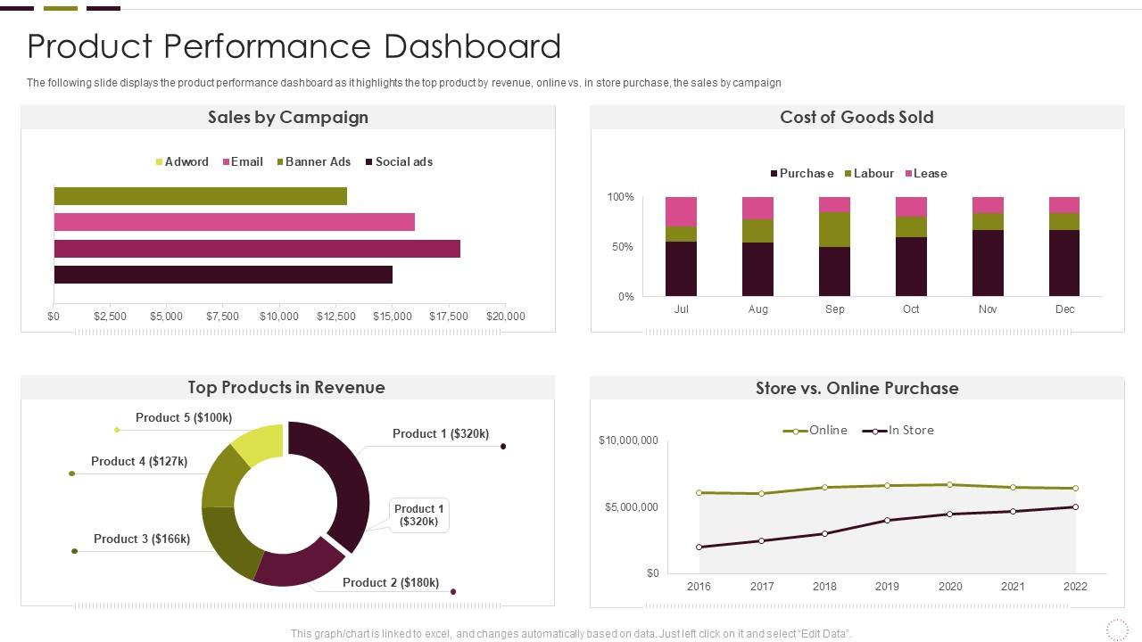

Above dashboard shows the product performance over the pretesting, concurrent testing and post testing.

- First chart shows the sales date through the different kind of marketing technique in first 6 months.
Most efficient marketing was the banner ads which generated approx. $18,000.

- Second chart shows the purchase rate of chair increased over the time.
From 50% to 65%.

- Third chart shows the Generated revenue through the product after every upgradation during the Concurrent testing and Post testing.
Most of the revenue is generated through the first product or the base model of product i.e.
$320,000.

- Forth chart shows the purchase of the product through the online mode and from the stores or offline mode.
- Where the online purchase is more over the offline or in store purchase and here online purchases is constant throughout the period where the store or offline purchase was increased over the time.
Both online and offline purchase generate the revenue of $6,500,000,000 in 7 years.

Result & Conclusion:
- By identifying target audience, we recognized the issue which helped us to create the whole new product based on the real-world requirement.
- With the help of unique design and the advance heating/cooling system we created the unique identity in the gaming furniture sector which provide the whole new experience to the user.
- By promoting our product with the strategic marketing techniques, we reach the vast majority audience for who we specially design this product.
- In the pretesting phase we identified flaws and worked on it to do improvement in the product to ensure the better experience before the launch.
- With the user feedback we able to do evolution in our product and set new benchmark’s that helped us to stand alone in market and gain the customer trust.
- In this way we made unique brand identity among serious gamers, streamers, and esports professionals achieve enhanced focus in gaming through unique design, bladeless cooling technology, and adaptive smart features of the chair.

References:
https://www.razer.com/
https://en.wikipedia.org/wiki/Gaming_chair

